Casa Vietii

House of Life
Happy 2008

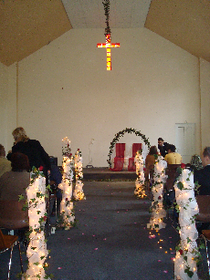Before we talk about 2008, let me bring you up to date with what happened at the end of 2007. First of all, in November we finally moved into our church permanently. Although our September Prophesy Conference met in our unfinished church, the first service after completion was the marriage of Ionela and Toni. Ione is part of the YWAM team and Toni is very active in the church, especially with the youth. What a wonderful way to celebrate with Ionela and Toni as we celebrated the house of worship God had provided to us. At the end of October, we had a visit from Judy and Jamie Parker from the St Chads Church in England. When they arrived back in England they spoke about the needs of Manna Church here and within a few weeks we had enough money to finish installing the central heating, 4600 pounds in total! Praise God. Was that not an answer to pray or what? Although the church still isn’t finished, we can meet there in warmth and comfort. Everybody loves it. This picture on the right was taken just before the wedding.
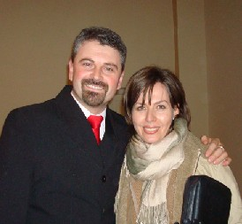 Talking about weddings, 2008 started on a great note. In the early hours of New Year’s day our pastor Pilu Hadearan, finally got down on one knee and asked Dolcemina to marry him . . .and, she said yes.
Congratulations to them both. We have so much respect for Pilu. He is an example for all of us and we are looking forward to working with Manna Church even more this year.
Pilu and Dolcemina

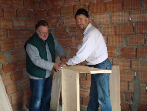On the 1st of November Sam, Jackie, Pete and Sue came on one of their regular, treasured visits to help with some construction. In just three days they managed to build a staircase in the new building. On the 3rd of November our dear friends Mary and Hamish came from Glasgow. They are always so encouraging to us and they are like our parents. Among many other things Mary (along with Jackie and Sue) took care of me (Jill) because I’d just come out of hospital having had my gall bladder removed. Hamish helped Sorin by installing a radiator in the new bedroom and he also tried to sort out the central heating at church because the first time we met there it didn’t work and we all froze.

Sam and Pete
Then on the 15th of November we had our first team arriving from Hemsworth church in Yorkshire. Again, as are all the teams that visit, they were a great encouragement. Olly and Jim came out and prayed for a girl in Soard who had just had a still birth. They spent a lot of time in prayer for us as a team while Paul and Will installed a velux window in the new bedroom. They also spent some time visiting several families in the villages. It’s good to know that they’ve been infected with the “Sighi bug” and are coming again in the spring to continue the work on the new building. Praise God!
Already for 2008, we have a evangelistic outreach team that includes a dental team coming from Alabama at the beginning of April. They will not only be working with the members of Manna in reaching out to our city, but also with many of the ladies here and in the villages. The first building team will hopefully be arriving at the beginning of May, another builders team at the beginning of June and a mixed team of youth workers and builders in October. God is bringing more and more people to Sighisoara and it is exciting to be involved in His ministry here.
We will be going to England for a couple of weeks in April to my niece’s wedding but will not have the transportation to try and visit any churches close by her city. Pray we get a chance to go again later in the year to bring our supporters up to date and show them what God is doing in the ministry.

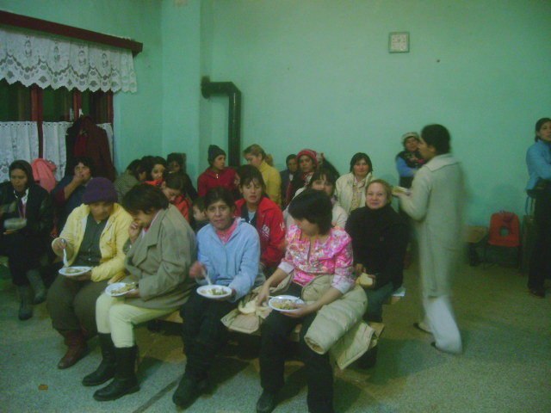The Christmas party for our ladies programs went great this year. We had all the ladies together at one party in Soard. Soard is our largest group and so it was easier to transport the ladies from our other programs to Soard. All the ladies gave a small amount of money to go towards the cost of the food, we went shopping and they cooked the food themselves. We had sarmele, which is a traditional Romanian dish. Cabbage leaves stuffed with minced meat and rice…..it actually tastes better than it sounds. Then we had all kinds of cakes and juice.

We had expected to receive a transport from Holland with food which we were going to make into packages for each lady. Unfortunately, through no fault of the kind people in Holland, we didn’t get them. It was too late to arrange any shoeboxes and we were worried that the ladies weren’t going to receive any gifts for Christmas. But God is bigger and more exciting than what we can plan and He just wanted to show us that He is in control and not to panic…..again! Our friends Norman and Linda donated some food packages and then some funding came from someone in England who we hadn’t met and who hasn’t given before. We were able to buy the food and make up 60 packages of oil, rice, flour, etc., etc., for the ladies. HALLELUJAH!

This year was Jadyn’s first ‘real Christmas’. Last year she was only seven weeks old and didn’t have a clue. I dressed her up as Santa and sent her to wake up Sorin! From then on she was like a tornado around the house. I expected her to play more with a baby keyboard or counting drum which we’d bought but, no, she played with a wooden hammer, screwdriver and pegs….you see she might look more like me but she’s definitely her fathers daughter. She is so well behaved and so intelligent. . .definitely her mother’s daughter?? I have never seen a child so young have such a vocabulary. She says something new everyday! We are enjoying her so much.

I mentioned in the last newsletter that we were at a turning point in our ministry. After many months/years of praying we have arrived at a place where we feel that it’s time to make changes in order for this ministry to move to the next level. We are currently in the process of separating from YWAM Sighisoara. We see this as a positive move and we will be leaving with the blessing of the YWAM leadership here in Romania and with encouragement from our pastor Pilu. We have applied to start an association and are waiting for the papers to arrive soon. Hopefully within the next few weeks, we will be ‘Casa Vietii Sighisoara’. We will be working as partners with Manna Church and continue working with the churches that have been planted in the villages.

We really feel that we will be able to focus more on this ministry and grow more in the direction God is leading. After researching and talking to other similar successful ministries, I know this will give us the freedom to enlist and train more volunteers to cover more of the needs in Sighi and the villages. We are excited to already have four people who were previously with YWAM Sighisoara who want to return and work with our ministry. Obviously in the next few weeks we have a lot of things to resolve regarding the separation so please keep us in your prayers. Pray for our team, pray for our wisdom and discernment, and praise Him for His faithfulness. I wish I could go into detail about all the different things God is doing in our lives and His ministry. These are going to be some exciting days ahead and we are thankful that you want to be a part of this important work.

So, again, we have plenty of things to be grateful for, many answers to prayer. We have many other things to pray for. We cannot do all we do without your prayers and support.

- Completion of Medical Clinic and Women’s Shelter including the funds to buy materials and equipment
- Wisdom and discernment for making decisions on some new directions for the ministry
- Favour with officials and doctors when trying to help our ladies.
- That God would be glorified in all we do as we share the hope of Christ

Thank you so much for all your support and please don’t hesitate to contact me with any questions or comments.

Many blessings
Jill, Sorin, and Jadyn xxx

Please stay in touch. Let us know how we can pray for you. Contact us if you need any more information or if you have any suggestions. For donations to any of the projects or the operation of Casa Vietii Sighisoara, please contact me at jillascough@hotmail.com.

If you are in the United States,
please contact Barbara Glenn at tbglenn@gmail.com (Note: this is a new email address from before)
or
Choose Life, Inc.
2006 Franklin Street, Suite 204
Huntsville, AL 35801
256.534.1996
www.chooselifehuntsville.org
for tax deductible donations.

